Cloud and Serverless Computing Project

Sec-13  
ID:2000080043-Akhil

Assigned Project: Serverless Web Application in AWS

Get and Post employee details : API Gateway

Test REST Api : Postman api platform(free login)

Employee Business Logic : AWS Lambda service

Store employee details : AWS DynamoDB service

Create an IAM Role With Lambda as Use case and Policy:DynamoDB Full access

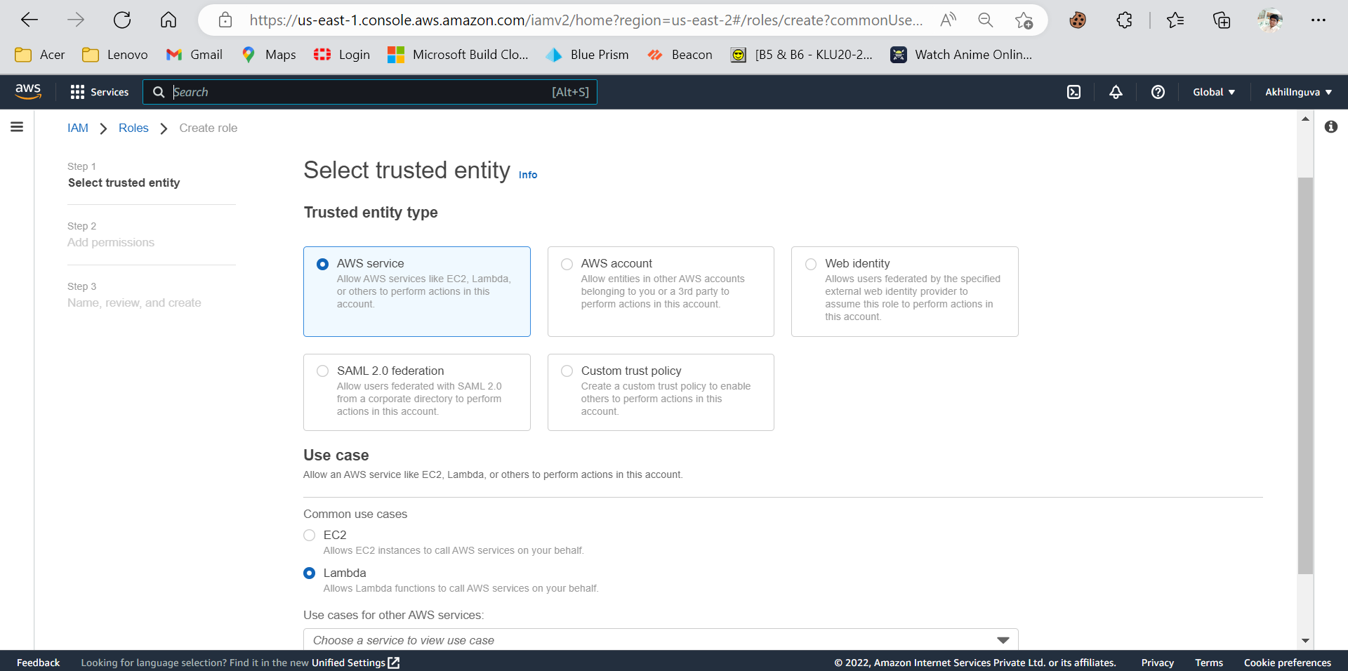

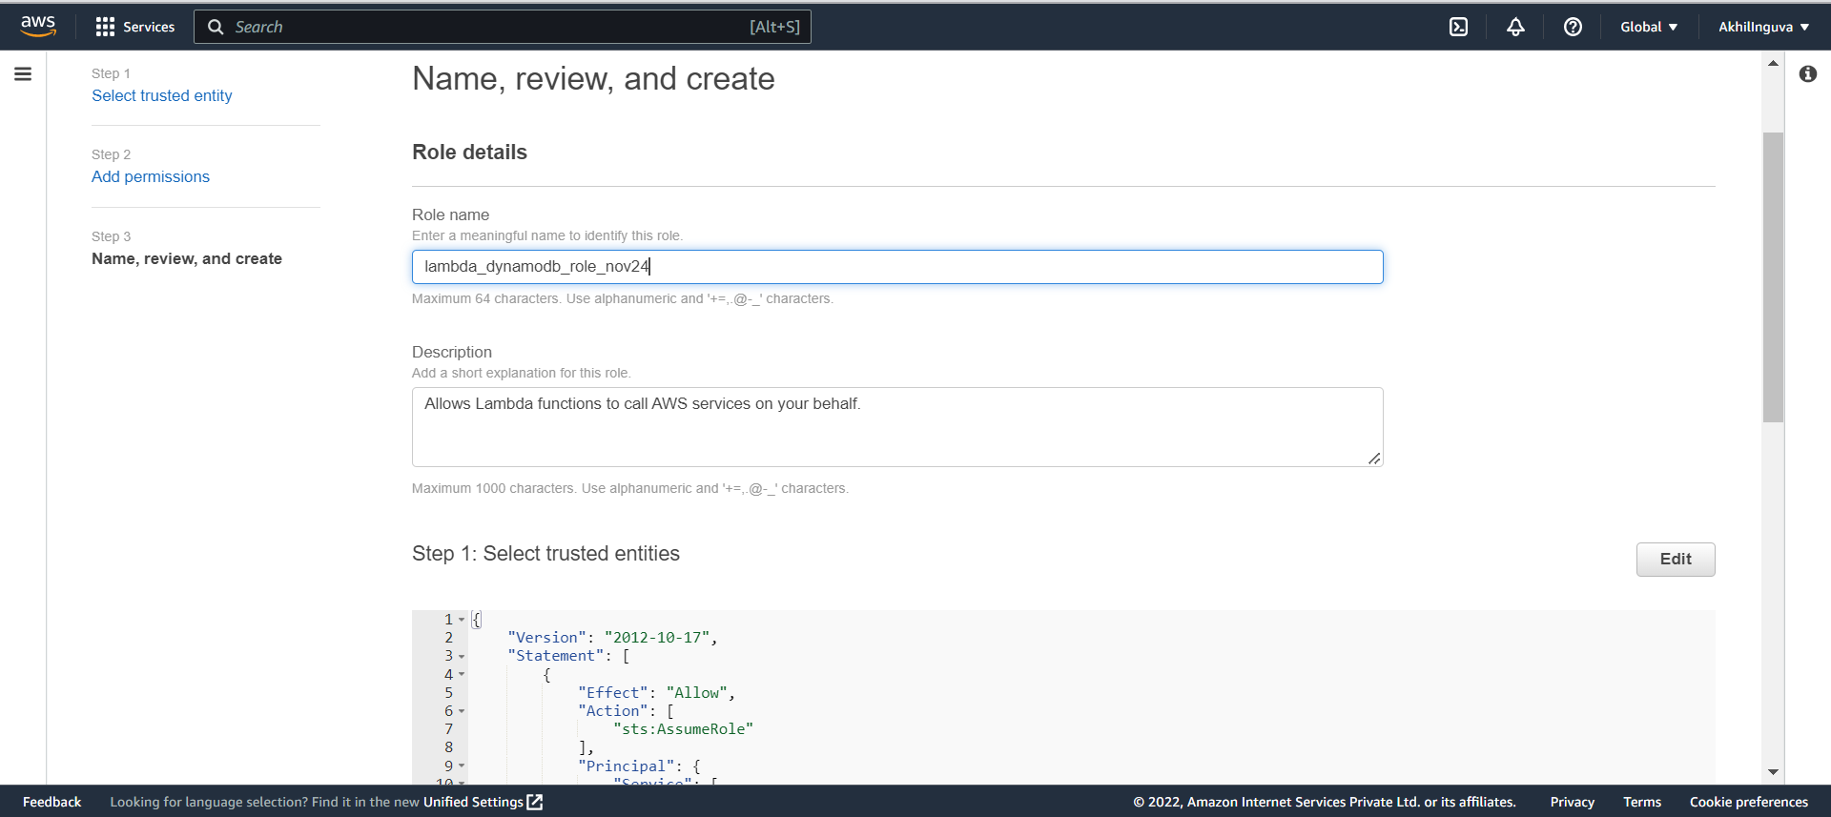

DYNAMODB:  
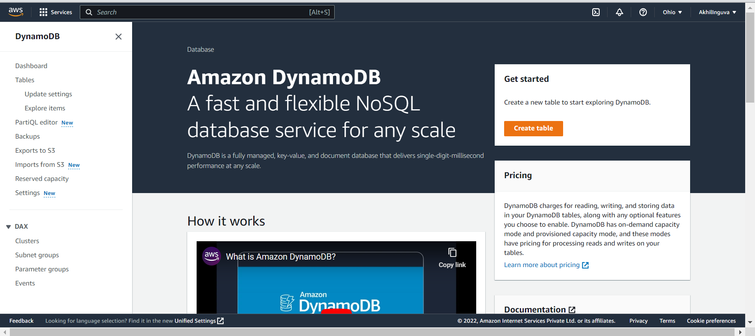

LAMBDA:

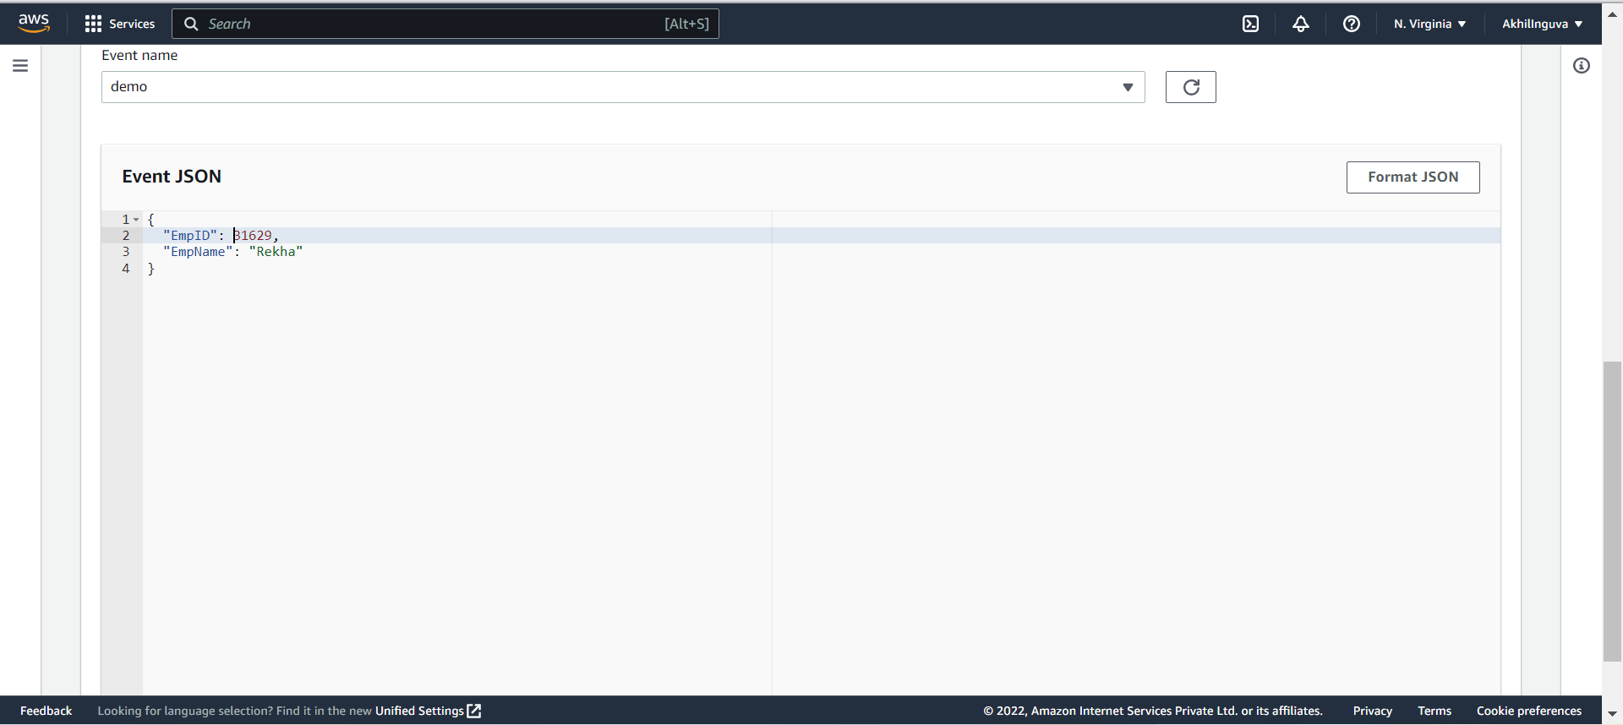

REST API:

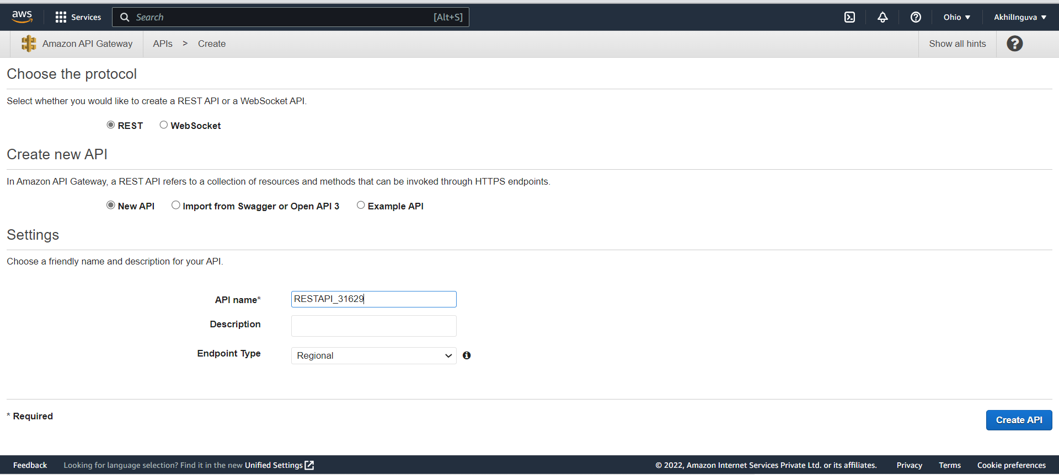

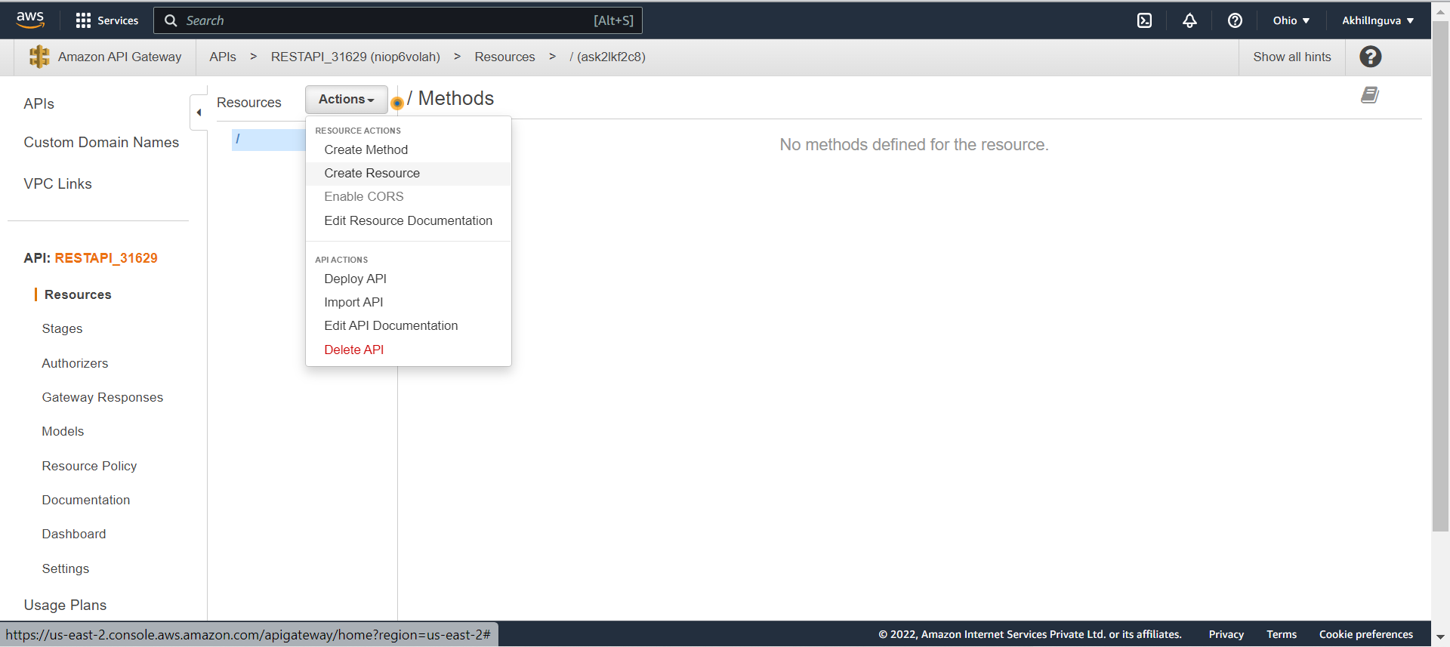

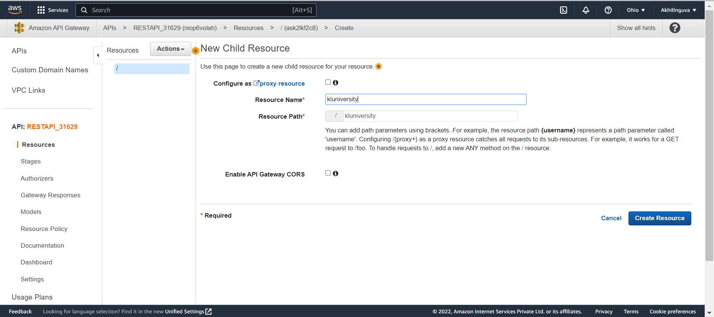

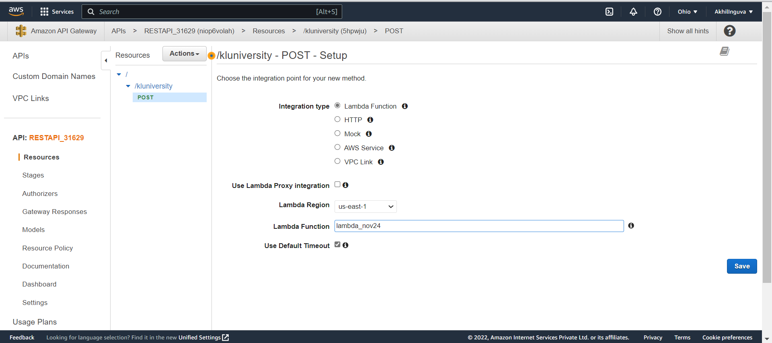

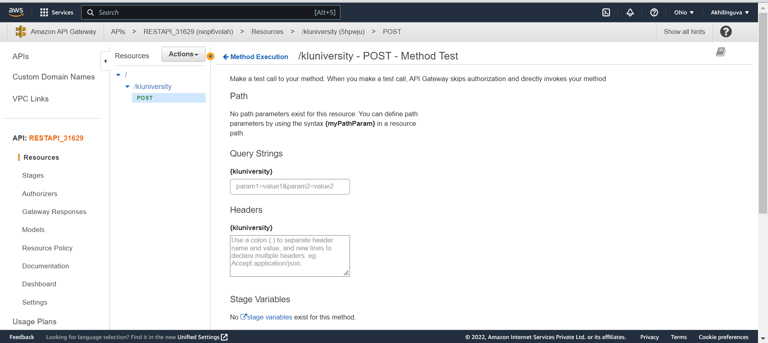

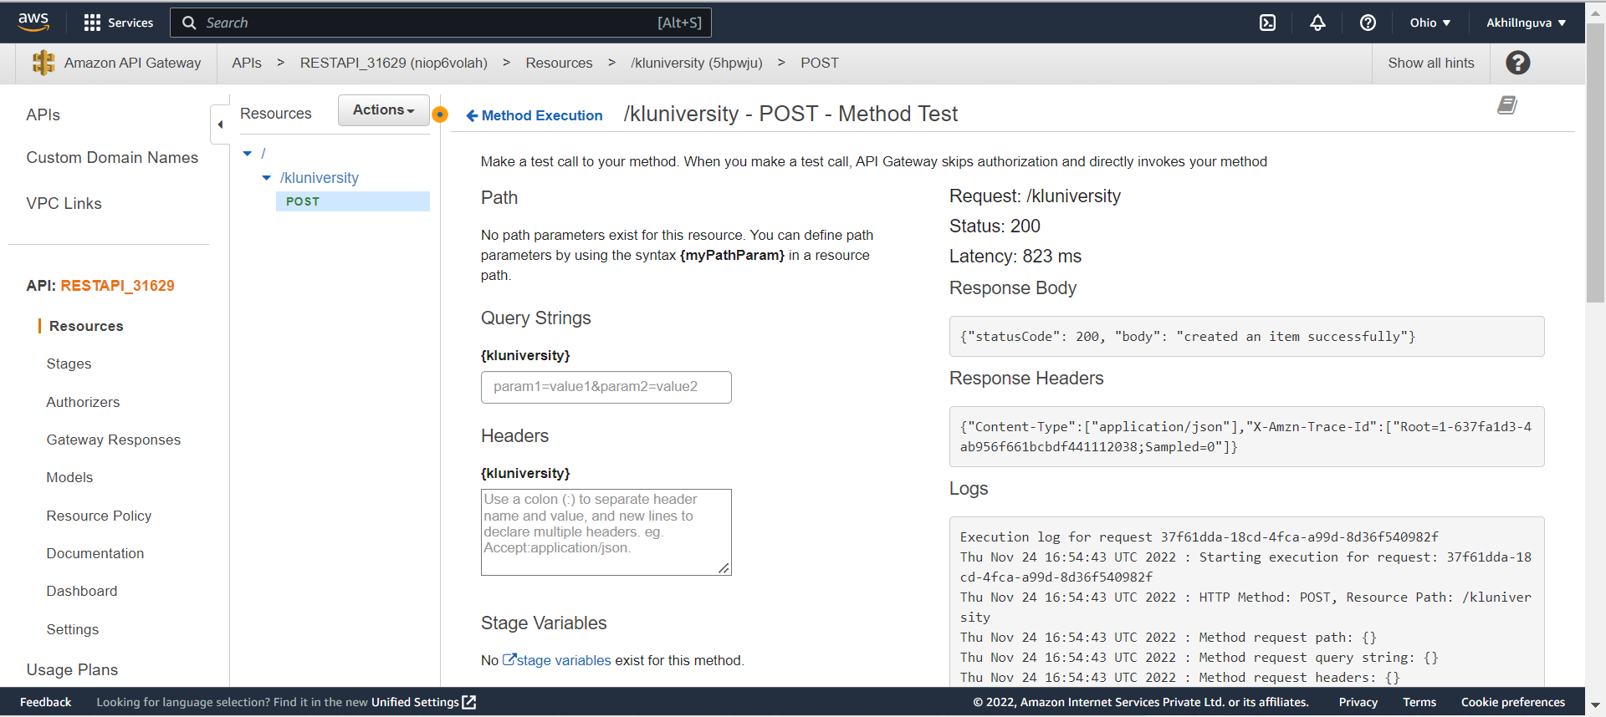

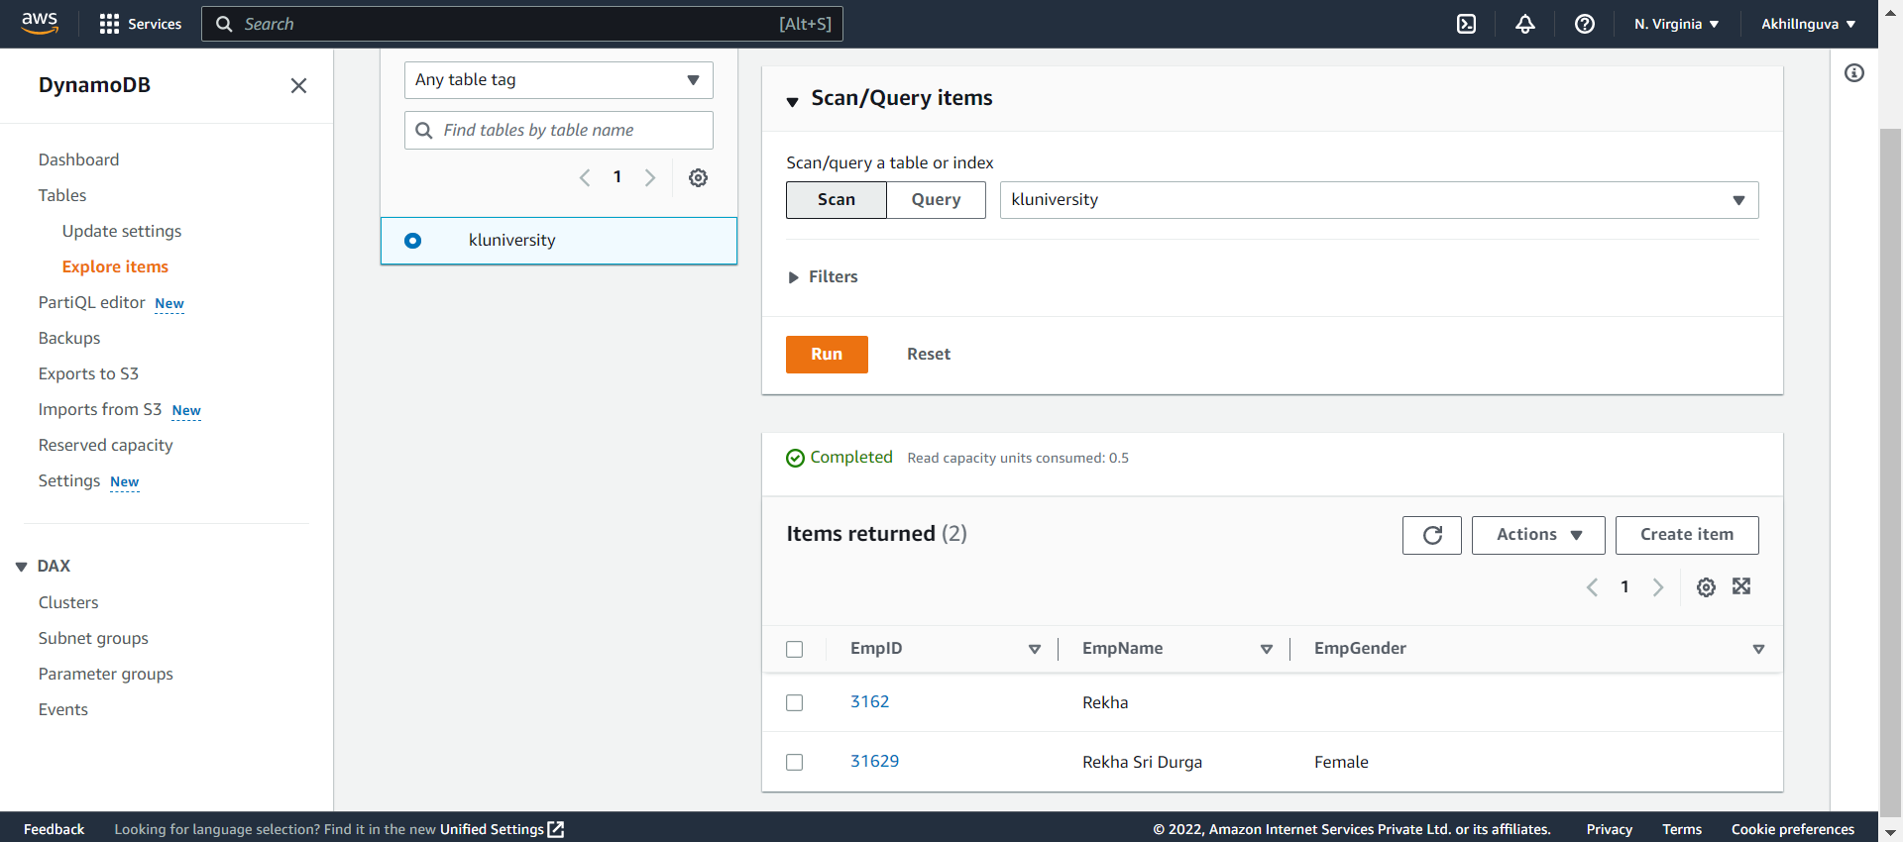

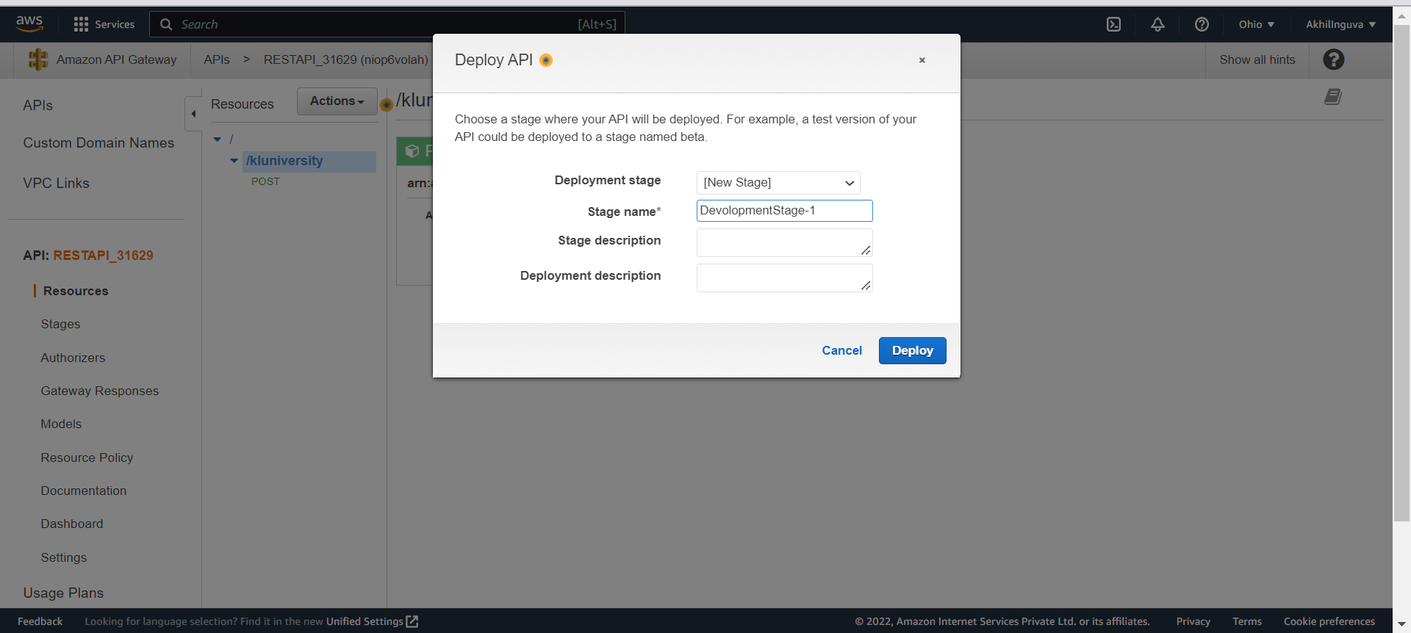

In above pic,we have created only one method POST,same as before create a method GET and select that and create the DeploymentStage-1

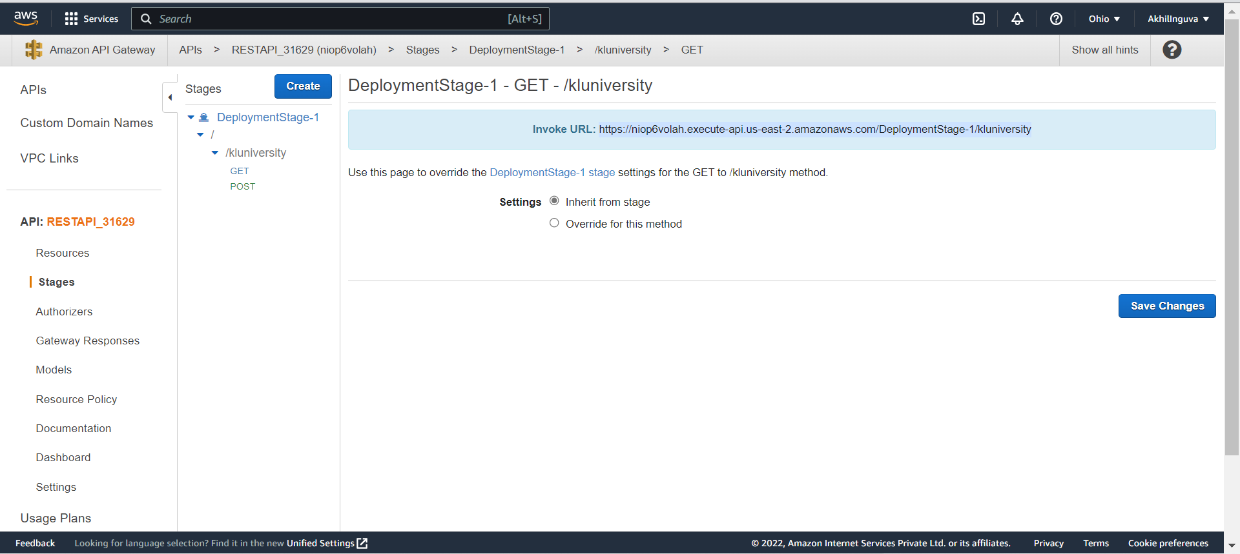

Copy the Invoke URL and open POSTMAN app

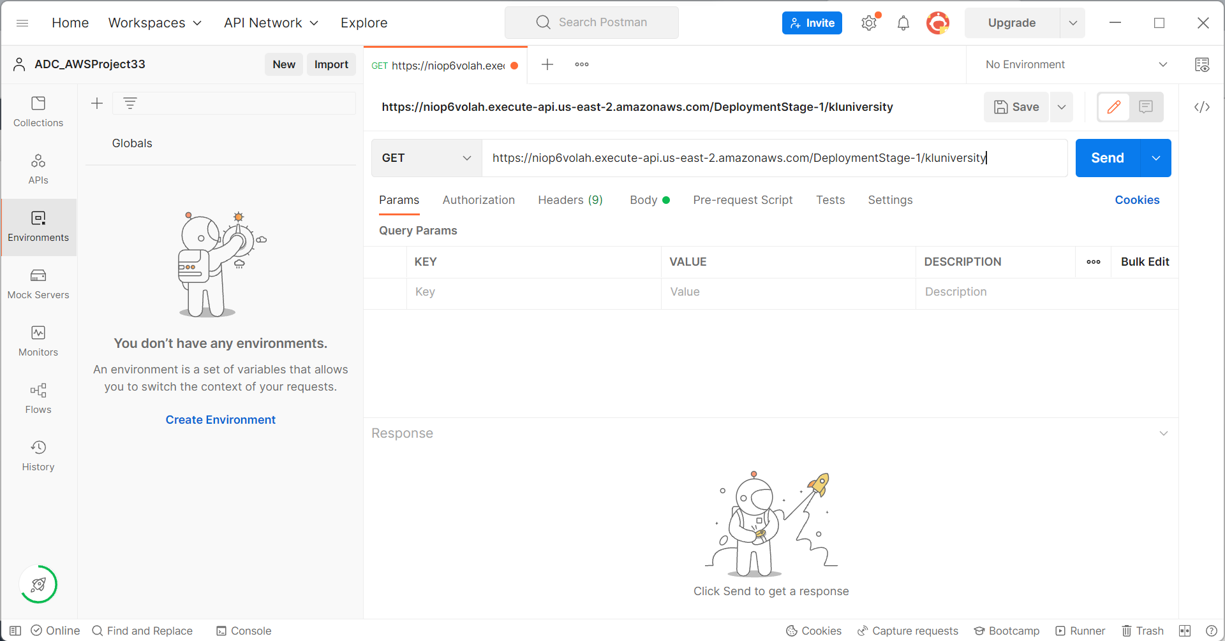

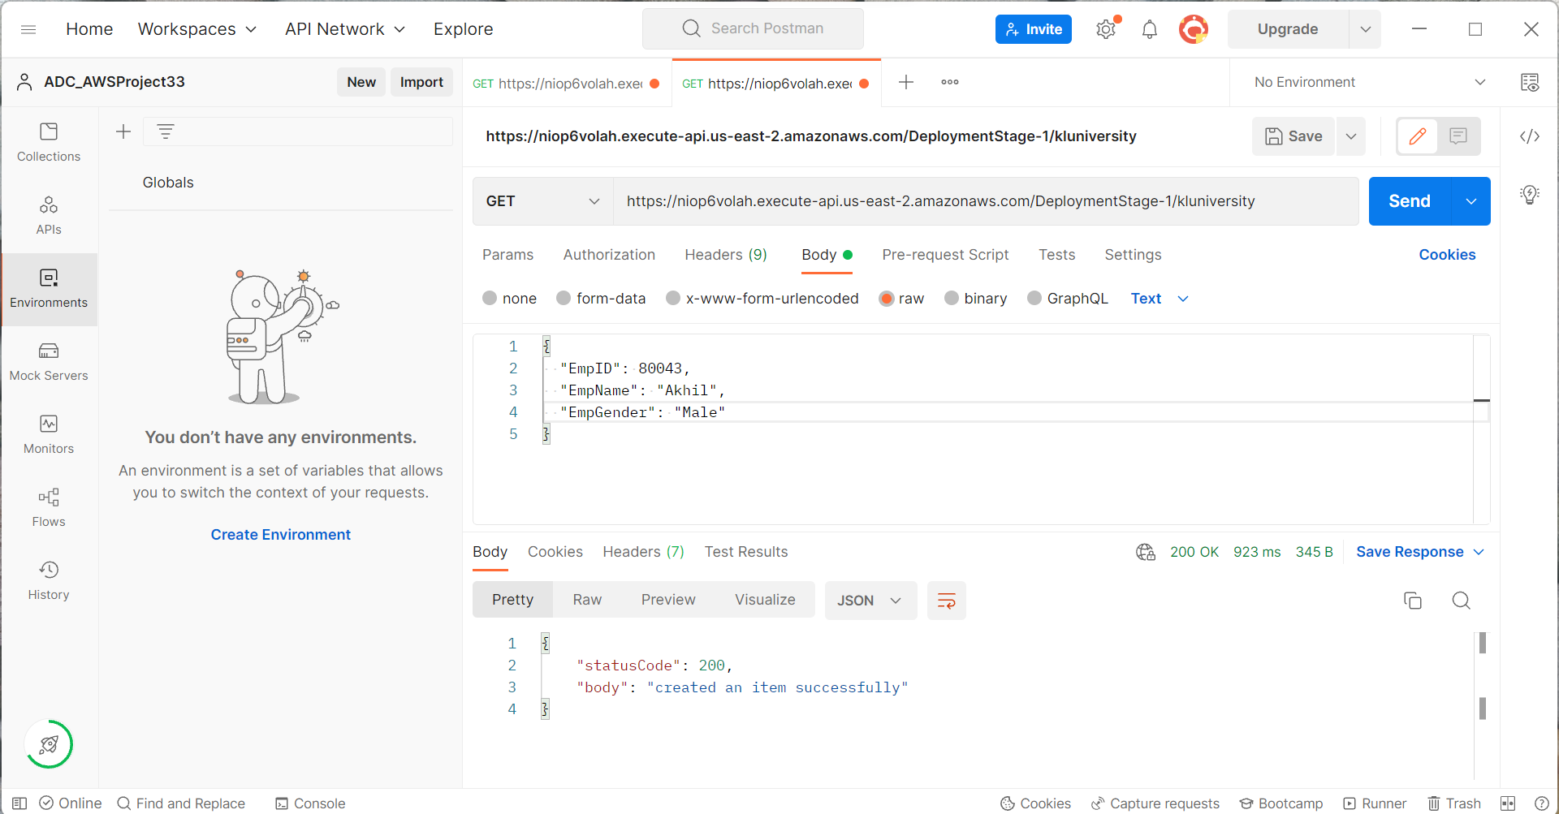

The Above Image Incidates created an Item Successfully due to the code in the Lambda Function is only creating an item….

For GET method to work ,in lambda function table.get_item(Key=event) is used in the code

Now this code has been executed,So go to Postman and execute it  
Output of GET Function in Postman:

